Tutorial
1

Lab Setup Guide
Software Requirements:
- VMware Workstation 26H1 (Installed on College machines)
- Kali 2026.2.iso
To create your lab, complete the following steps:
- Open VMware Workstation
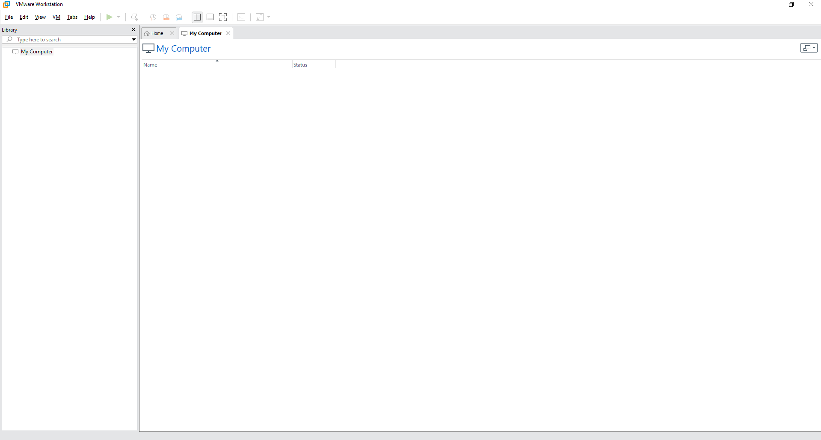
- Go to File > New Virtual Machine
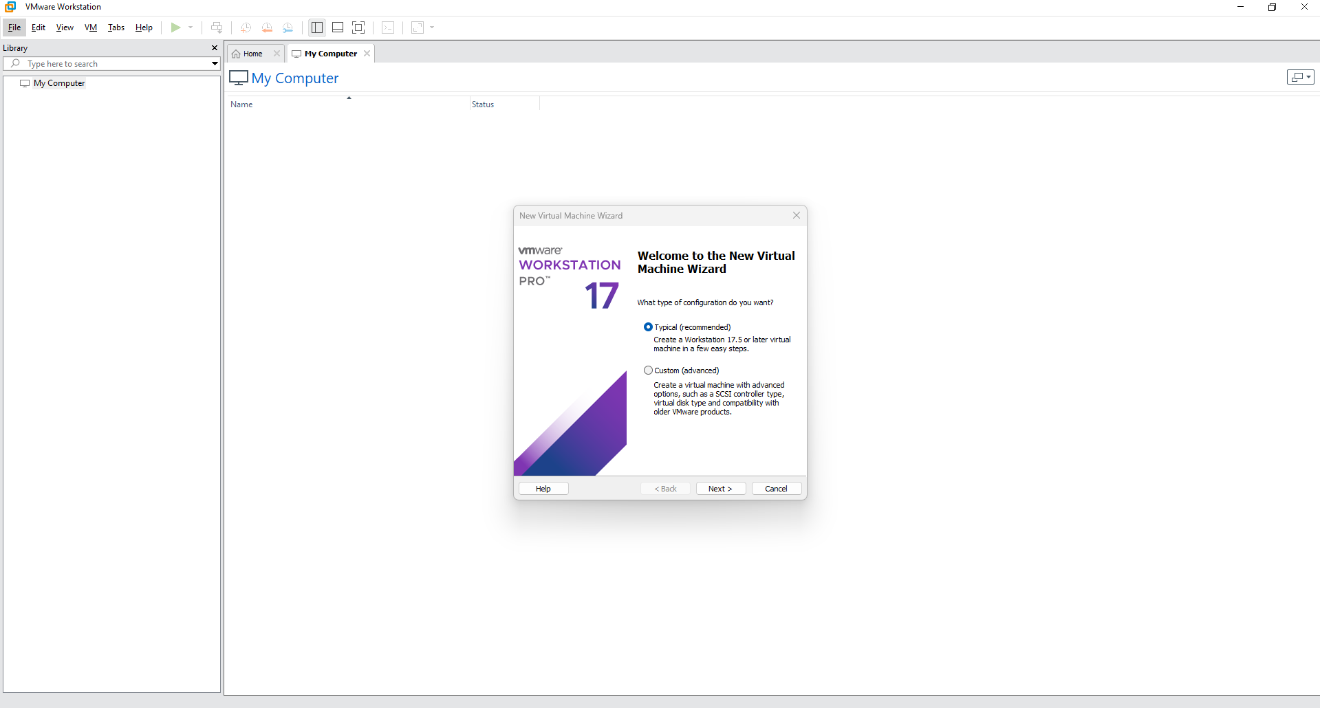
- Ensure typical (recommended) is selected for the type of configuration and click Next
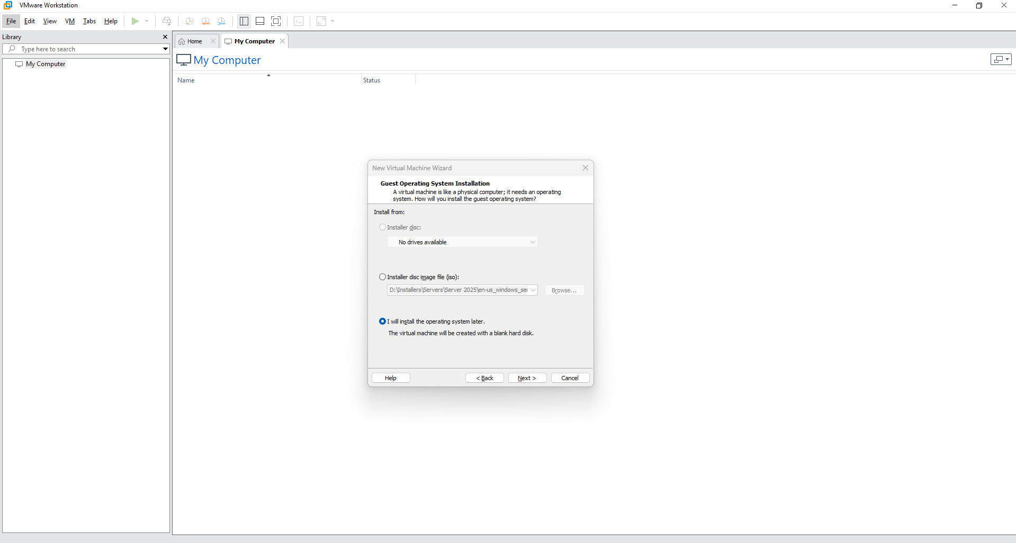
- On the Guest Operating System Installation page, select "I will install the Operating System Later" and click Next
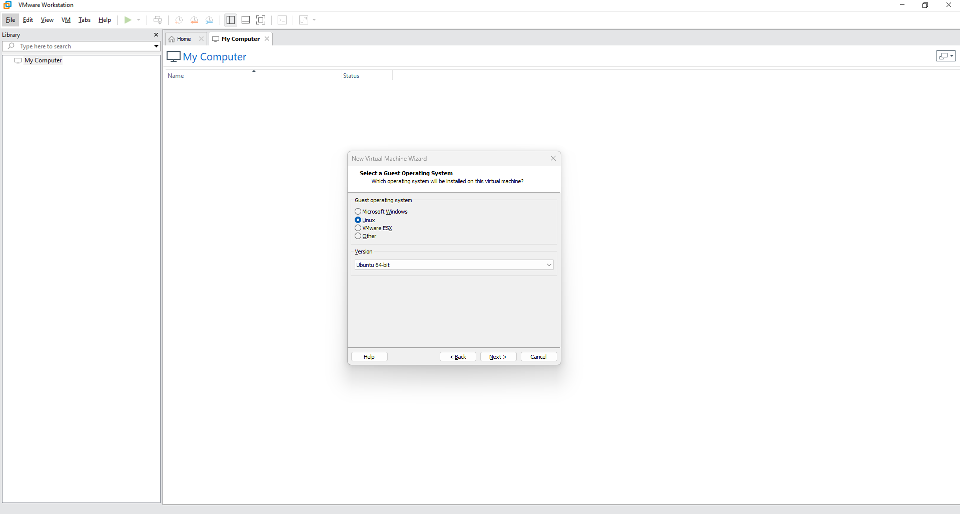
- On the Select a Guest Operation System page, Select the Linux radio button and choose Ubuntu 64-bit from the version dropdown list, then click Next
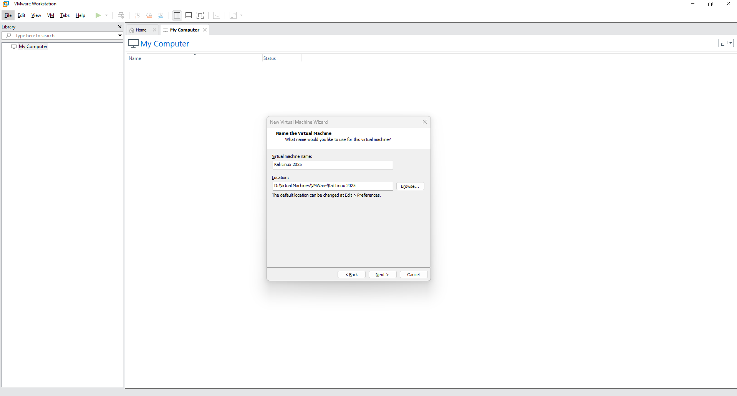
- On the Name the Virtual Machine window, call your virtual machine Kali Linux 2025 and choose a save location. If you have an SSD use that, if not, create a folder on the C Drive with your name and save it there. Do not save them to your profile. Click Next
- On The Specify Disk Capacity window, Set the Maximum disk size to 60GB and ensure that "Store virtual disk as a single file" radio button is selected. Click Next
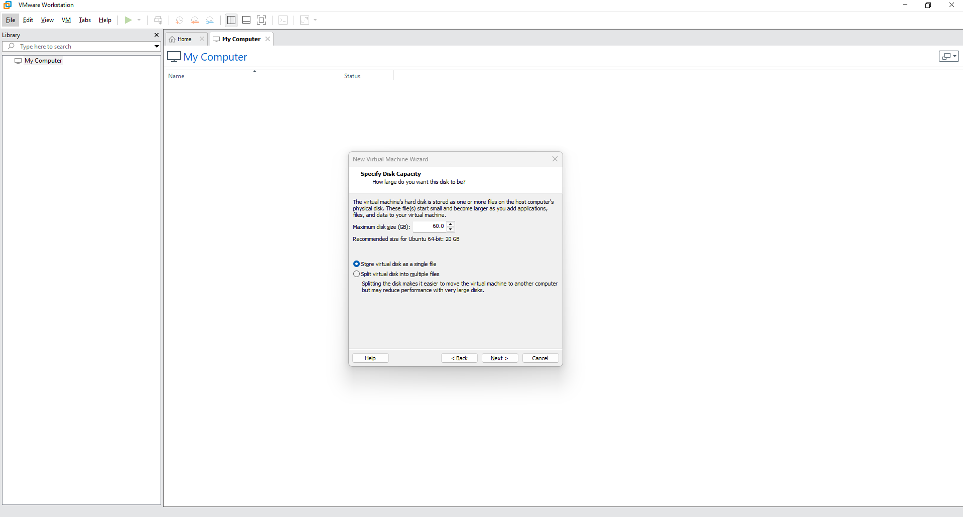
- On the Ready to Create Virtual Machine window, click Customize Hardware
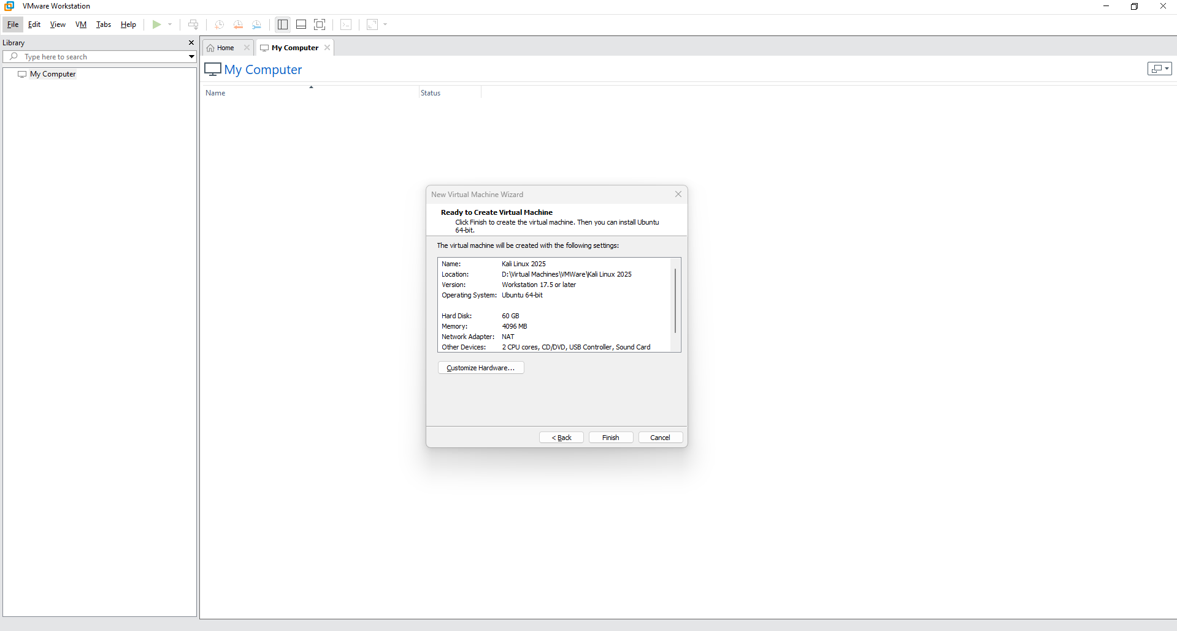
- In the Hardware window, in the memory tab, assign 8GB or RAM. In the processors tab, assign the Number of Processors to 1 and the number of cores per processor to 4.
- In the New CD/DVD (SATA) tab select the "Use ISO image file radio button, then click Browse. Navigate to the folder where your Kali Linux 2025.iso file is stored and select it
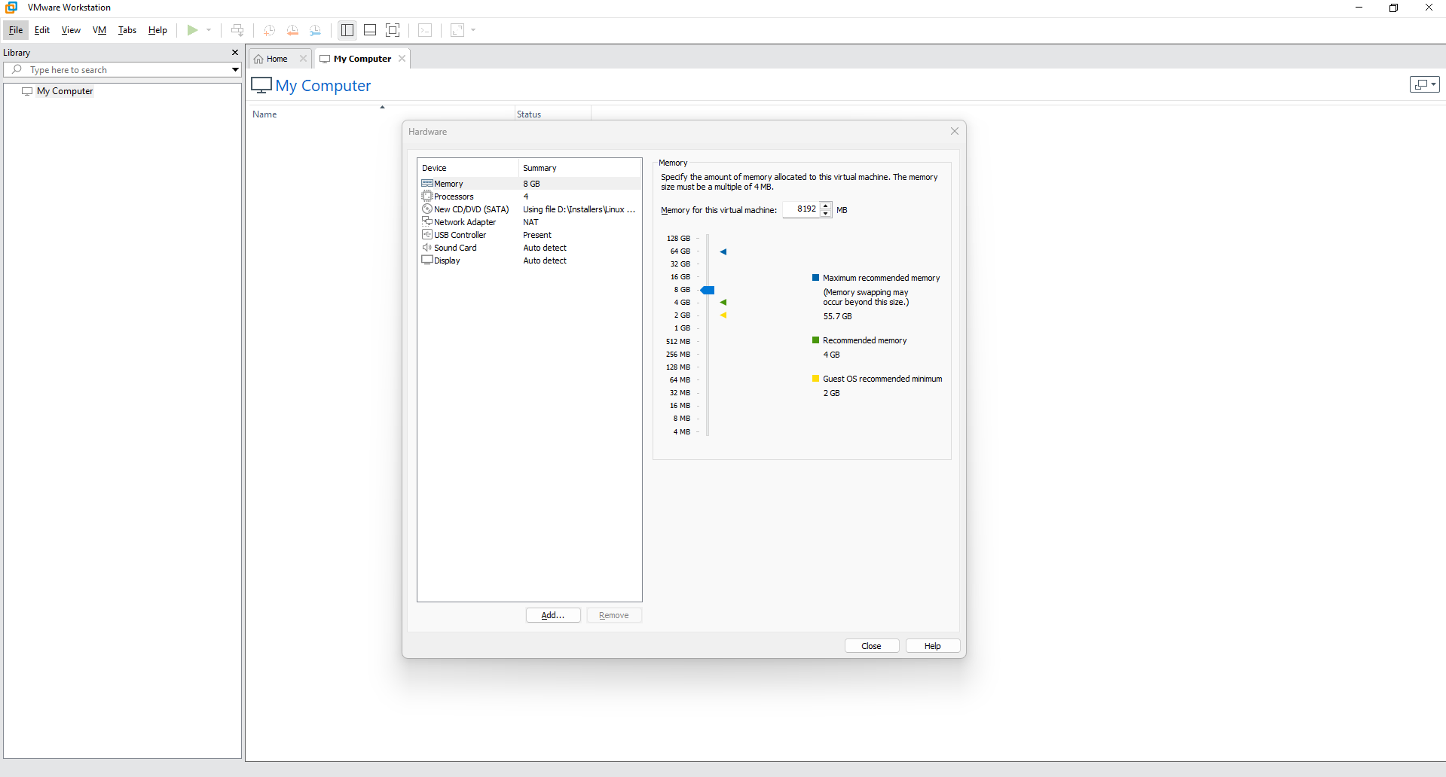
- Click Close to close the Hardware window, then Click Finish to complete the VM setup
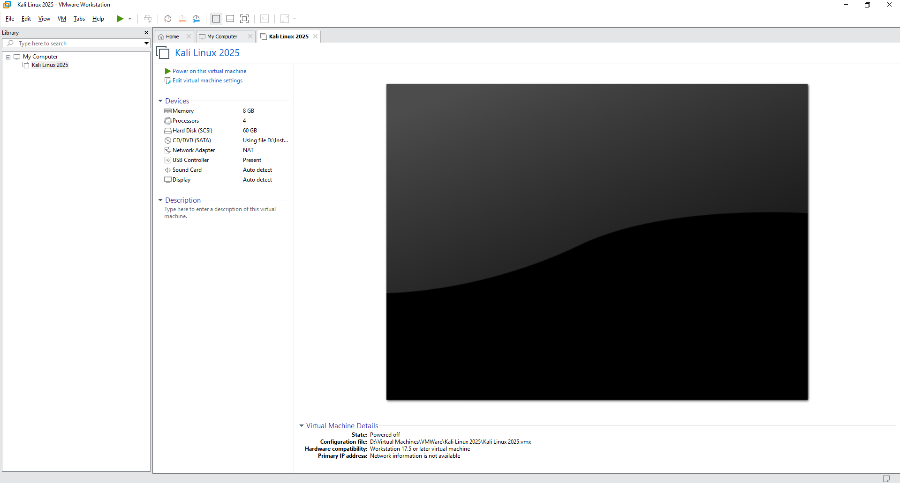
- To install Kali, Select your Kali Linux 2025 VM and click on "Power on this Virtual Machine"
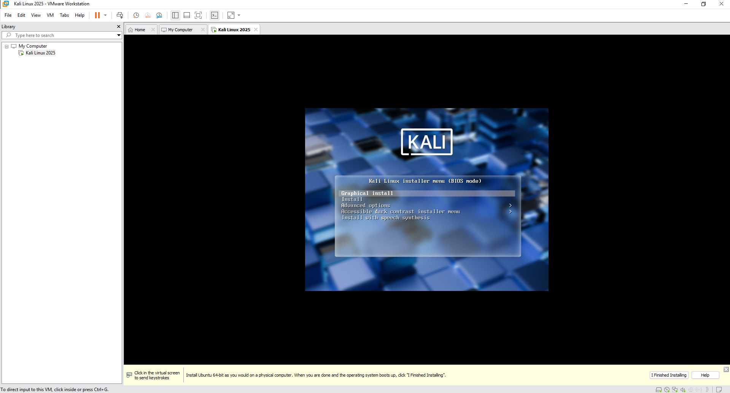
- Using the arrow keys, select "Graphical Install" and press Enter
- On the Select a Language page, Select English and Click Continue.
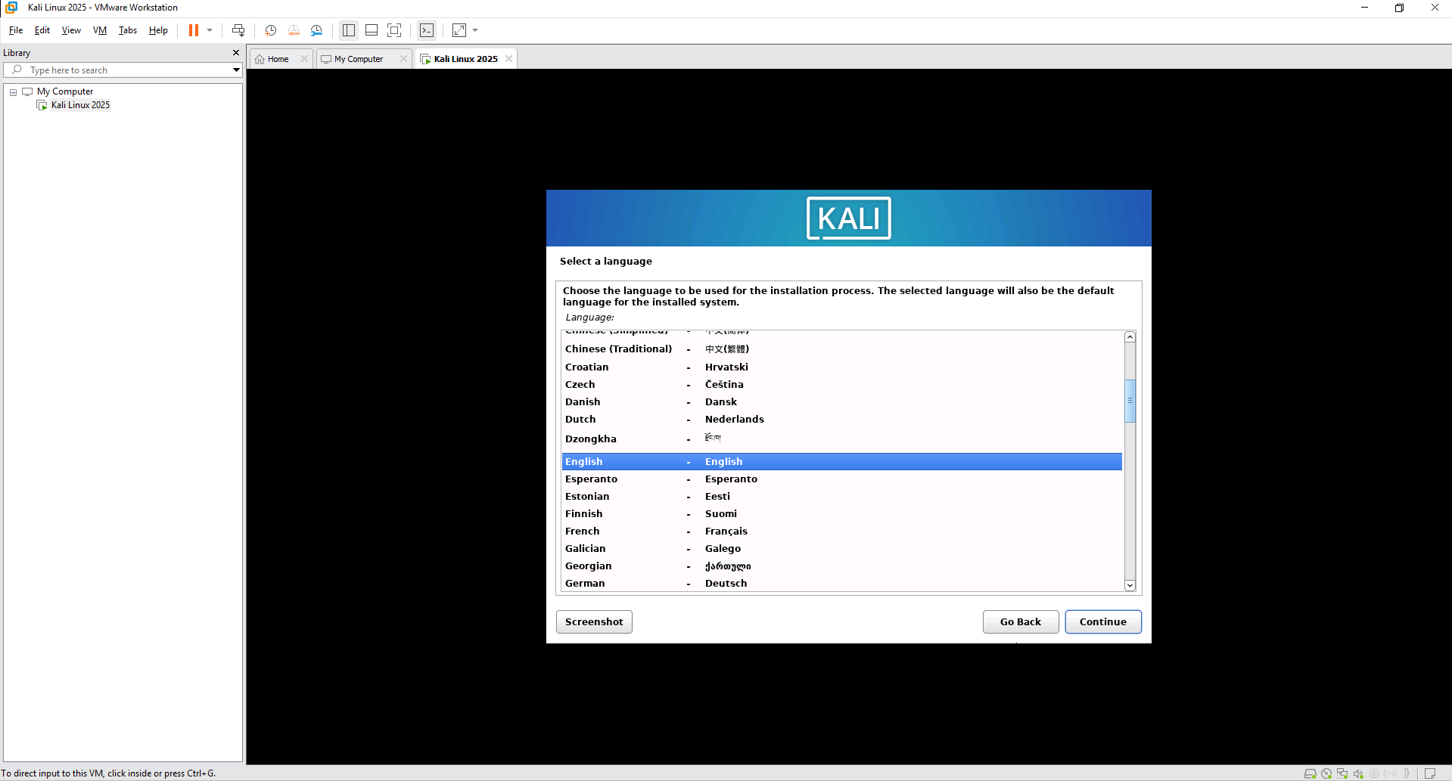
- On the select your location page, Select United Kingdom and click Continue
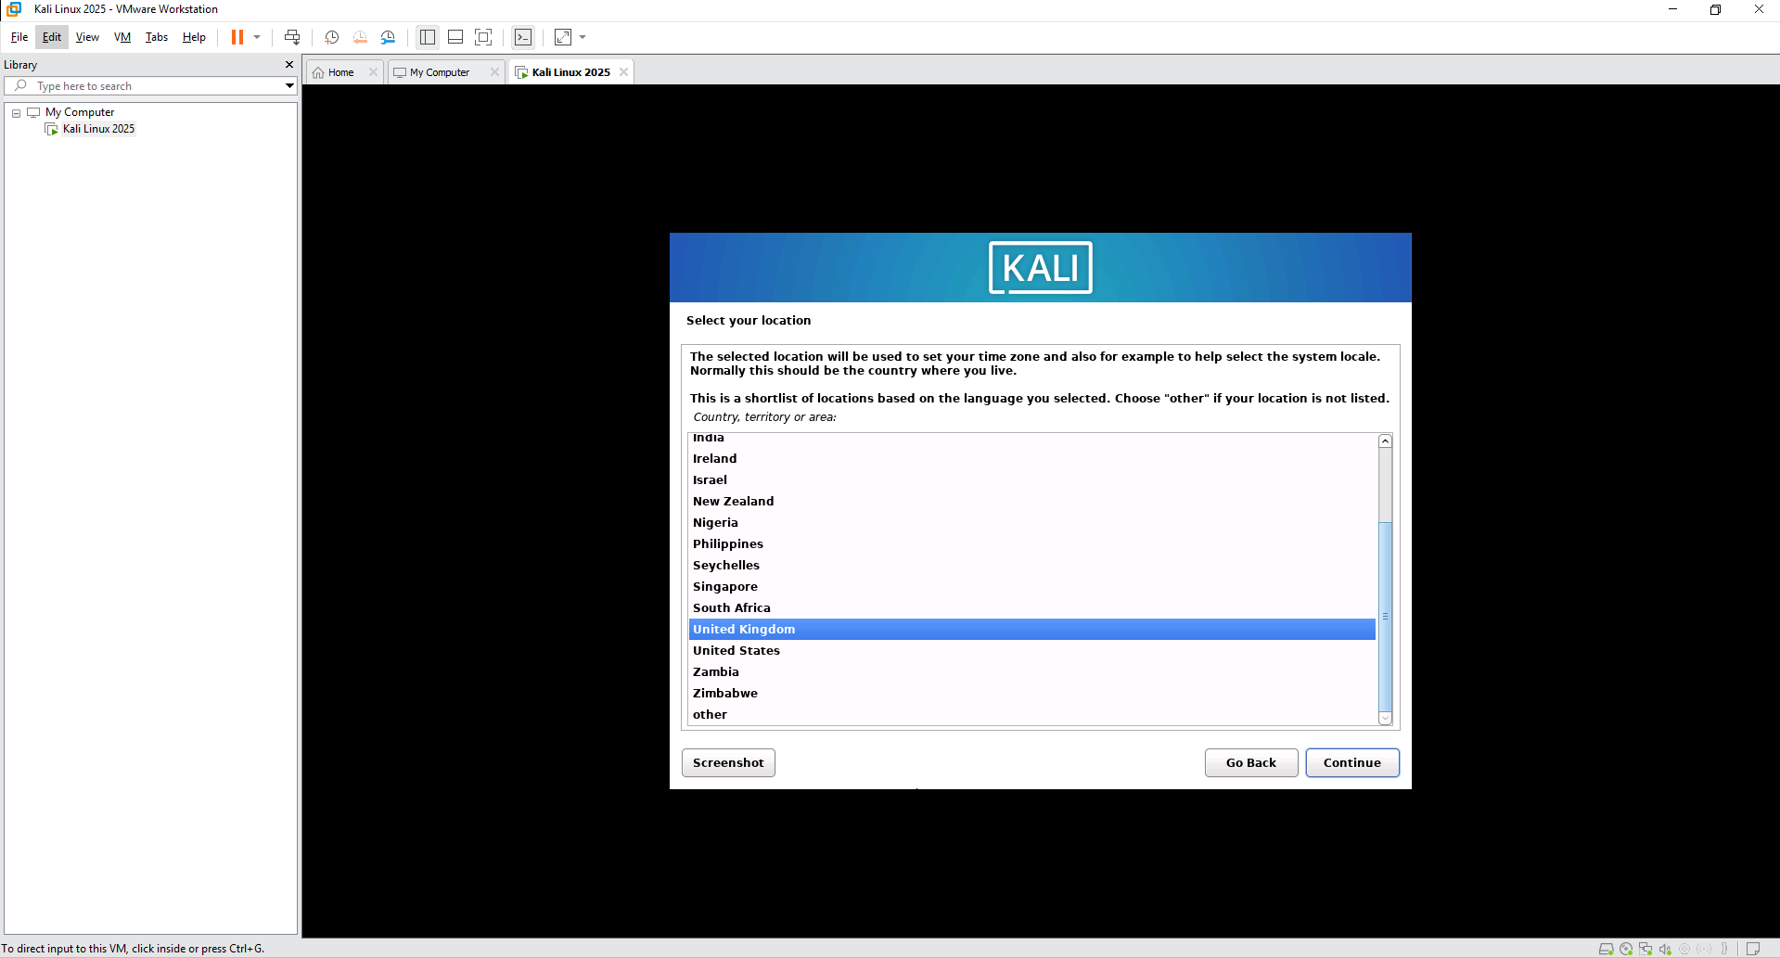
- On the Configure the Keyboard window select British English and click Continue
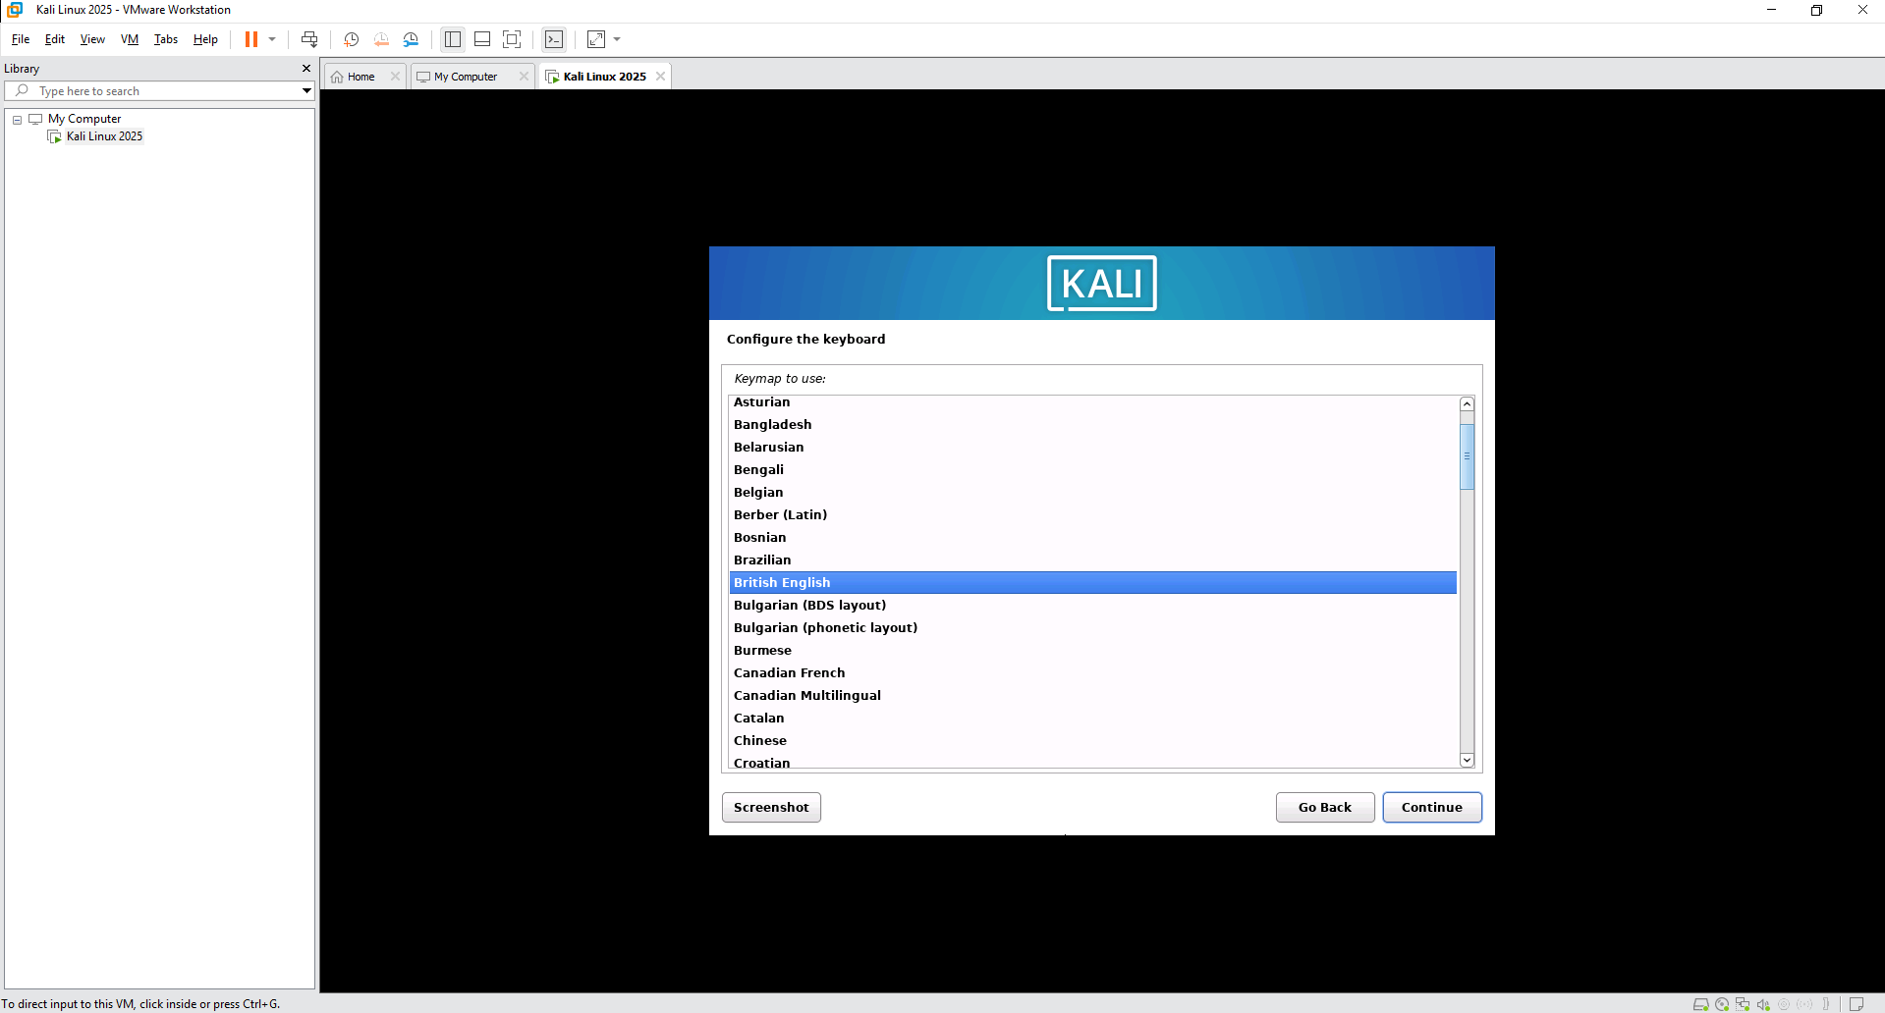
- The installer will start
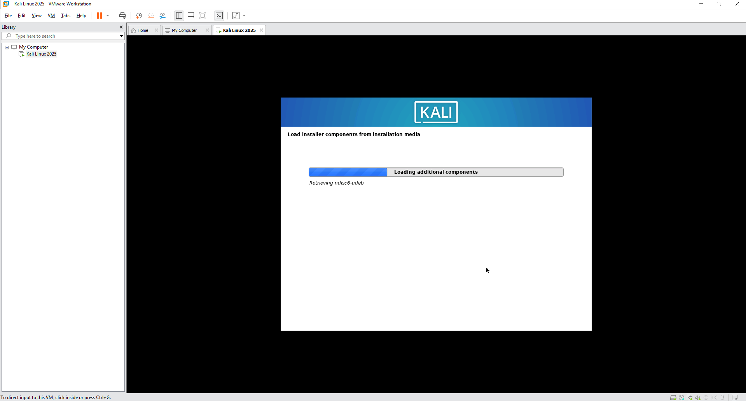
- On the Configure the network page, Click Continue and leave the default hostname as kali
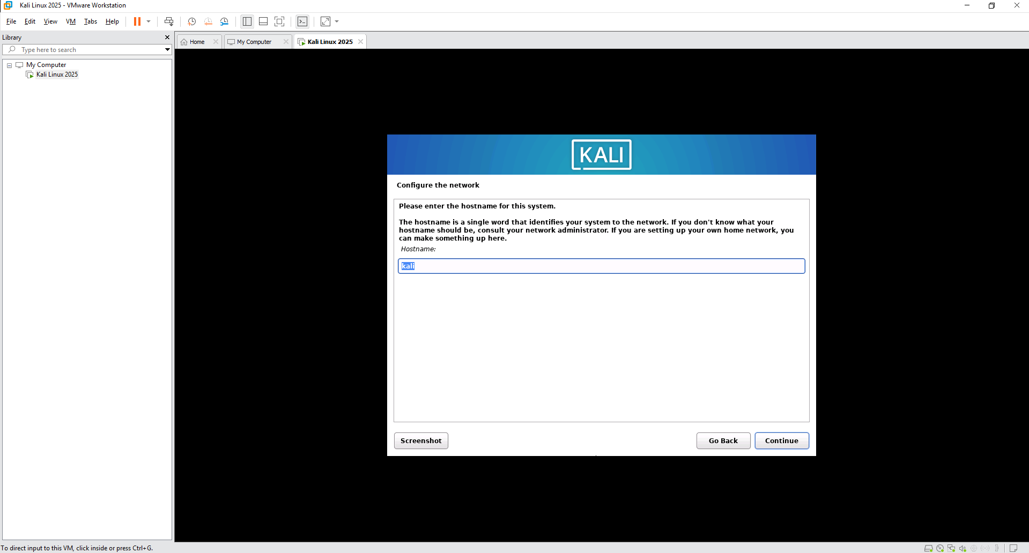
- On the Domain name page, leave the text box blank and click Continue
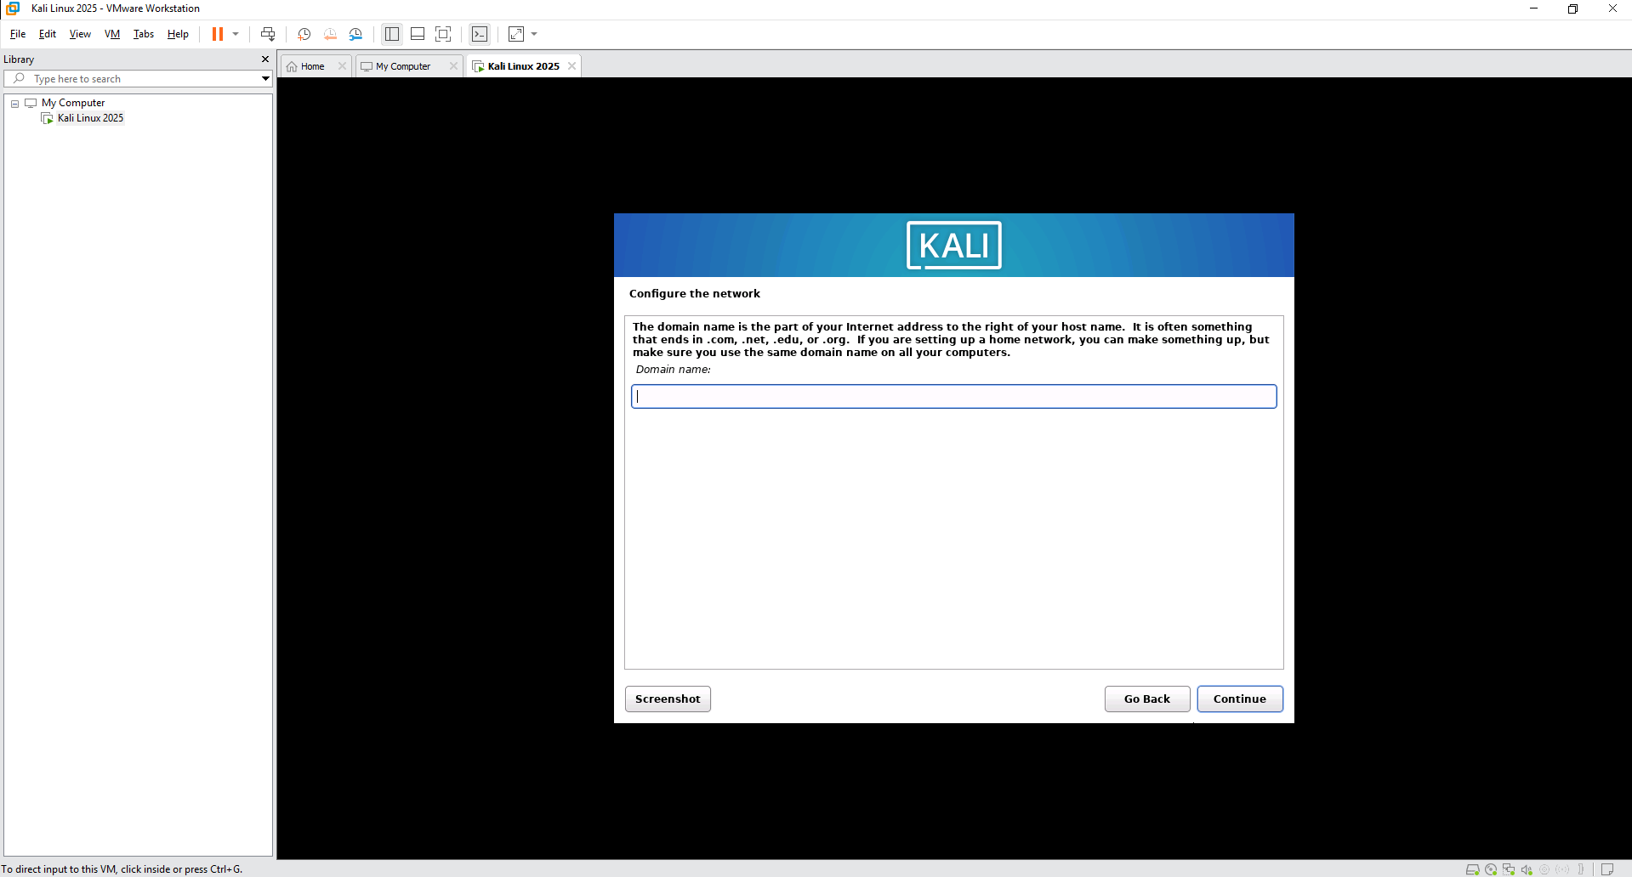
- On the Setup users and passwords page, give the Full Name as "student" and click Continue
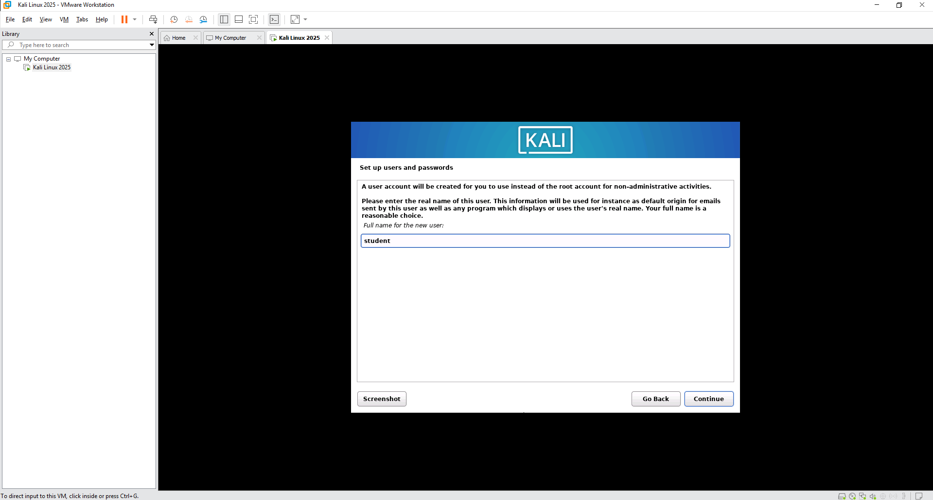
- On the Username for your account, use "student" and click Continue
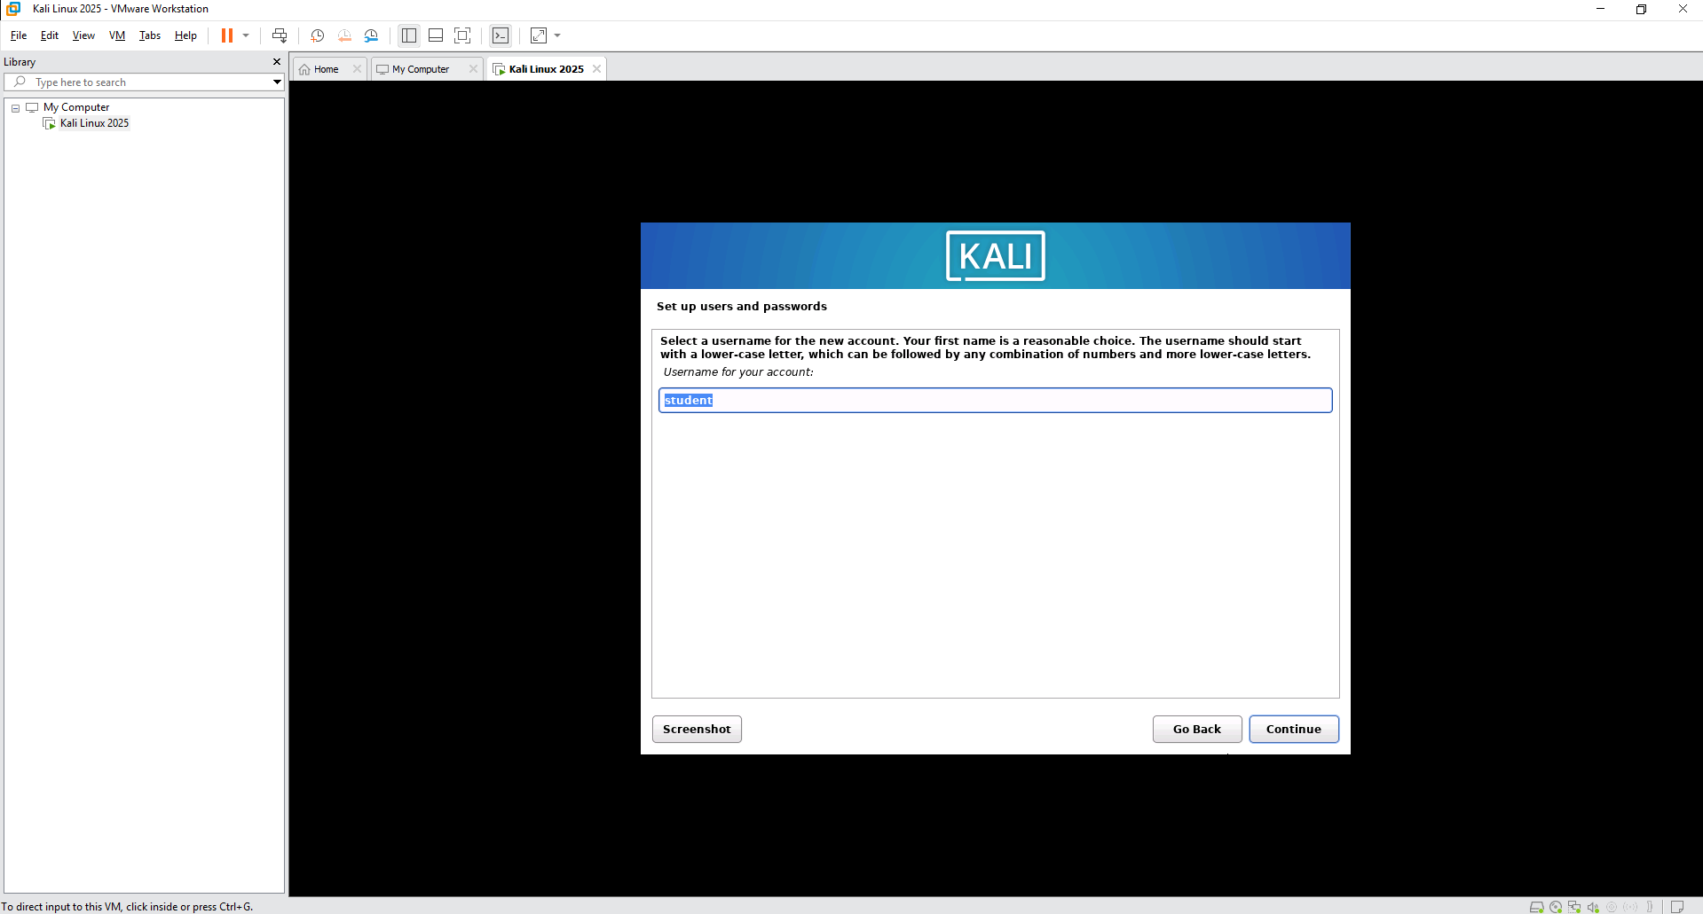
- On the password page, use the password toor and click Continue
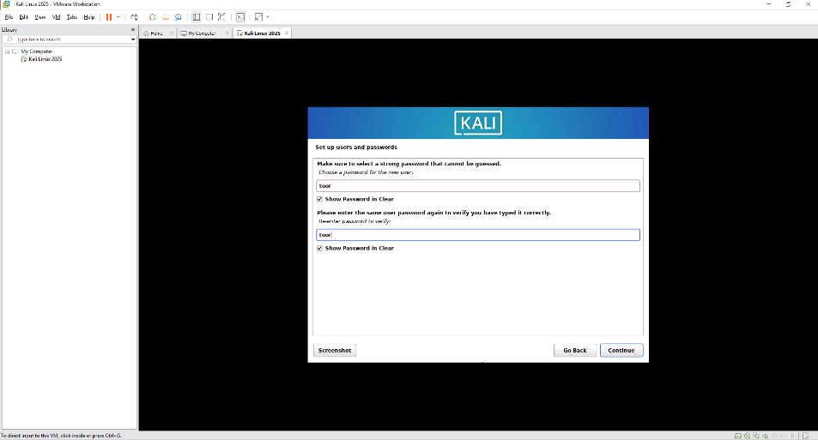
- On the Partition Disks page, Select Guided – Use entire disk and click Continue
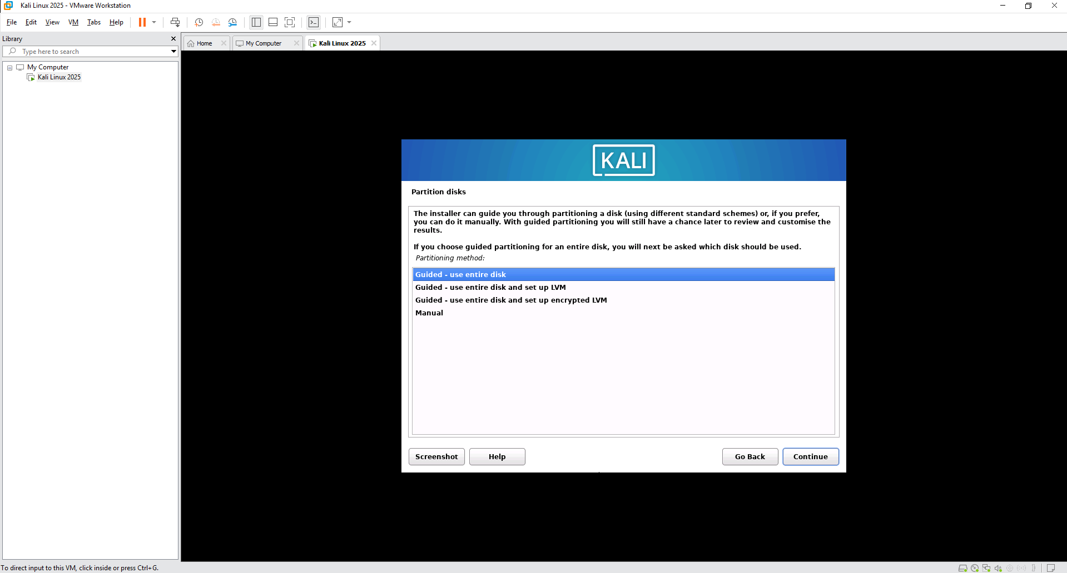
- Click continue again
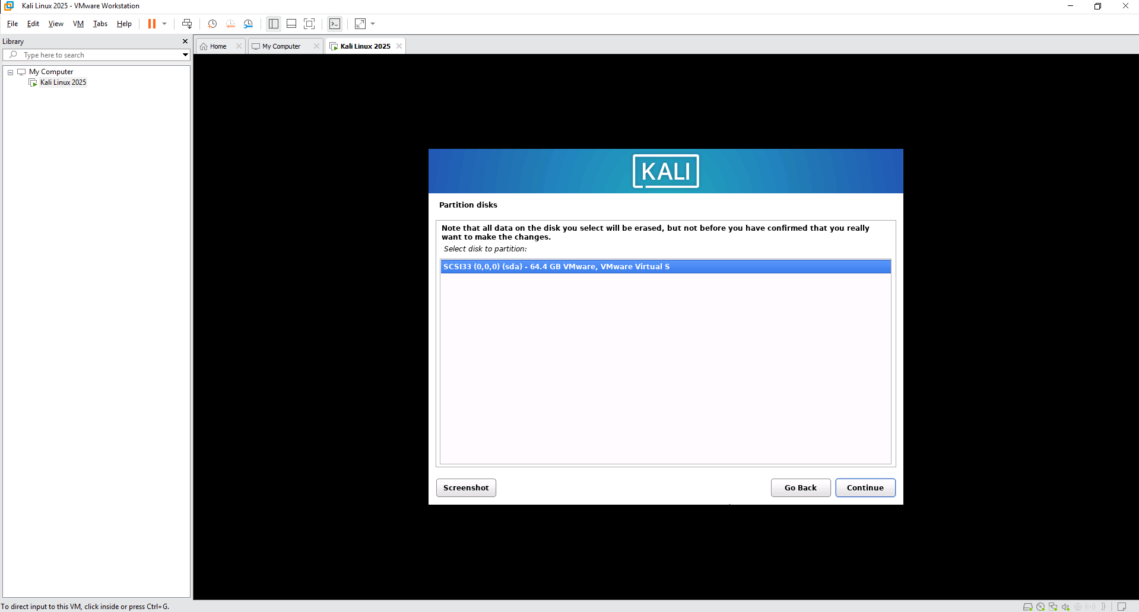
- On the Selected for Partitioning page, Click Continue
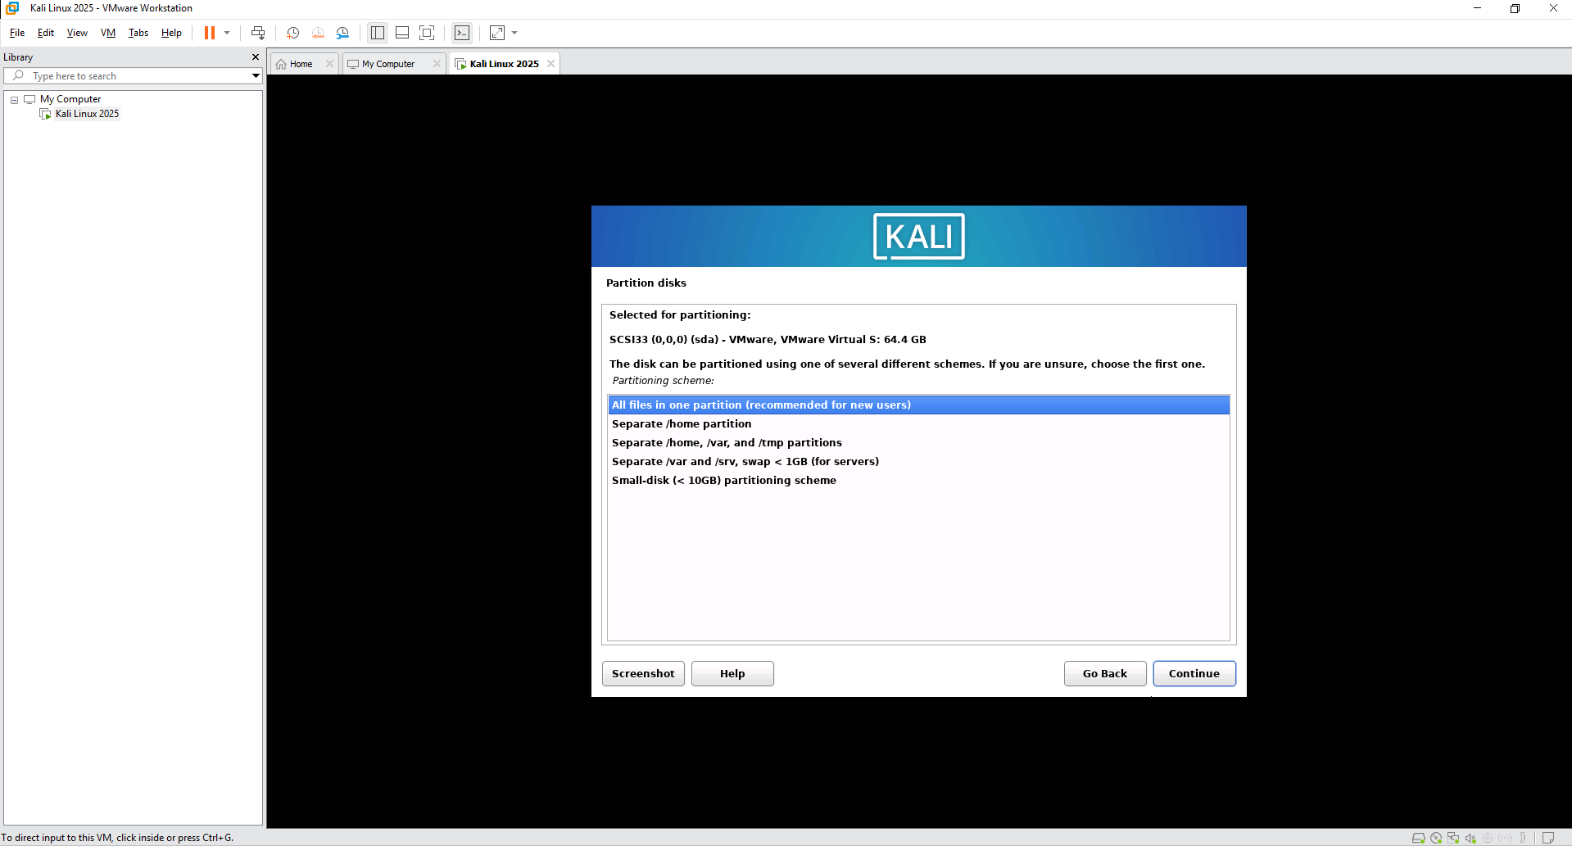
- On the Finish window, click Continue
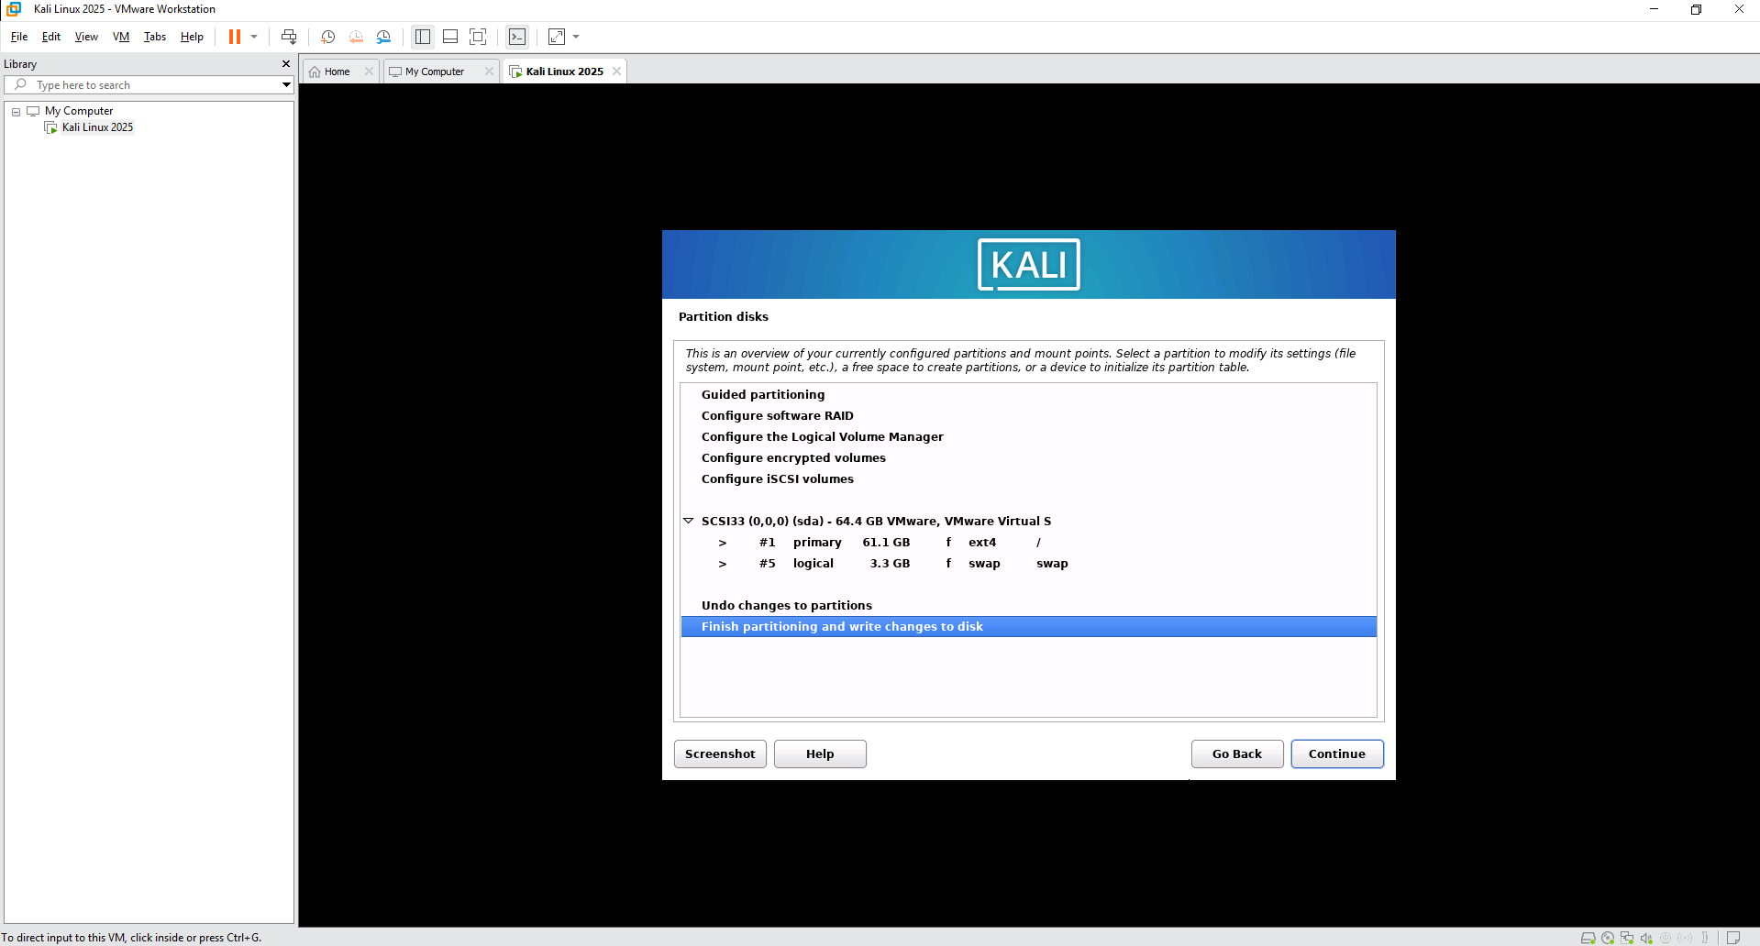
- On the Write the changes to disks window, select the Yes radio button and click Continue
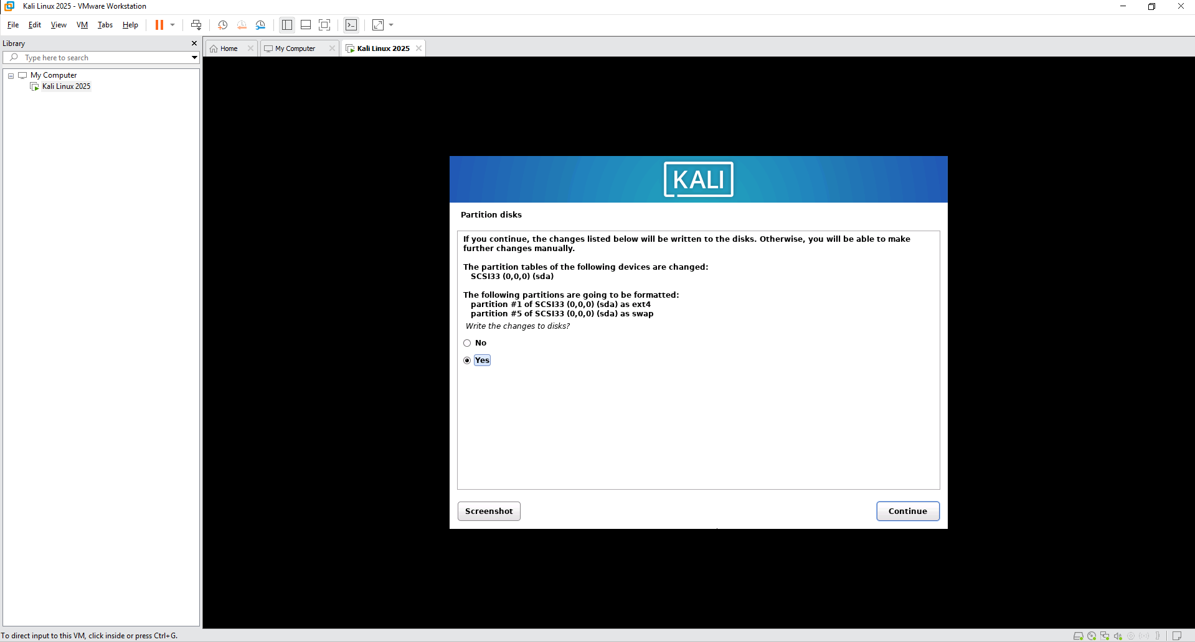
- The system will start installing. This process can take a few minutes
- On the Software Selection window, leave the defaults selected and click Continue
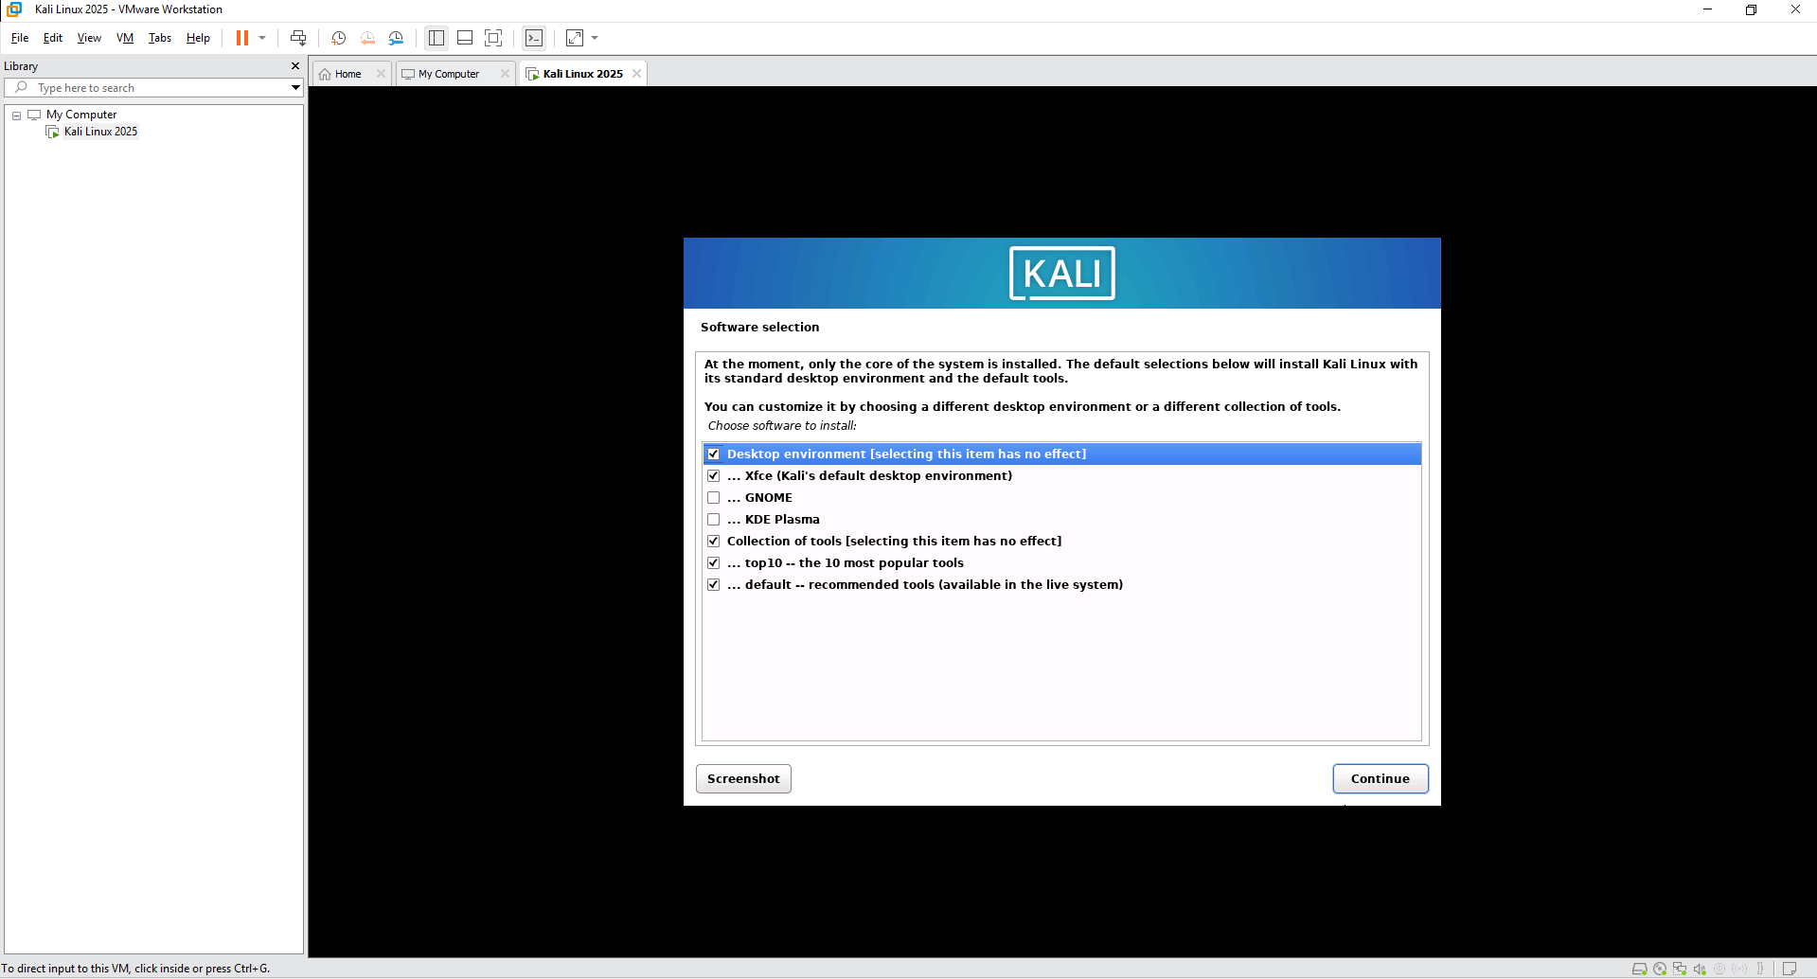
- On the Install Grub page, select the Yes radio button and click Continue
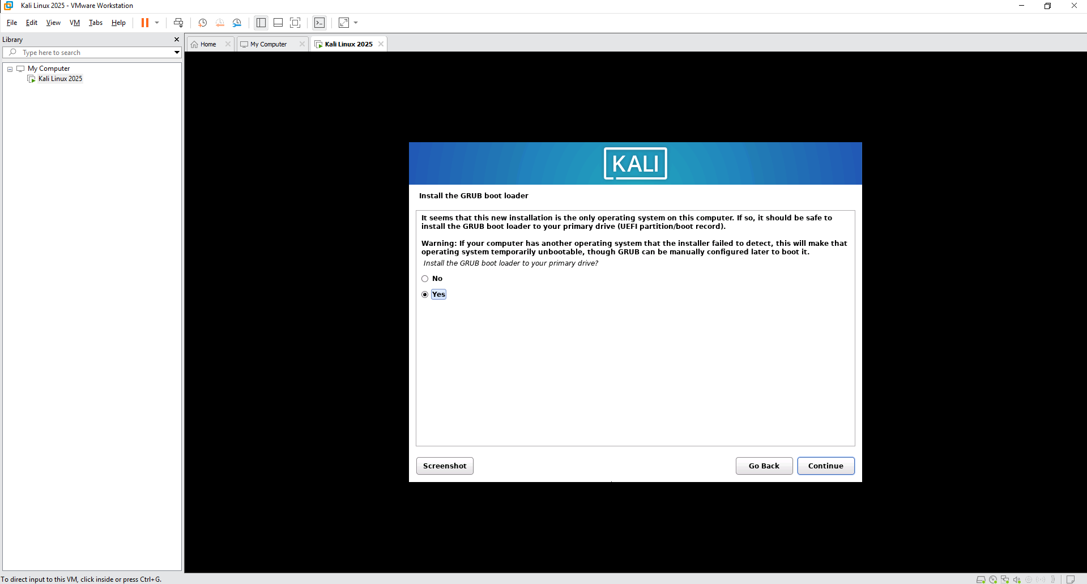
- Select /dev/sda as the location to install Grub and click Continue
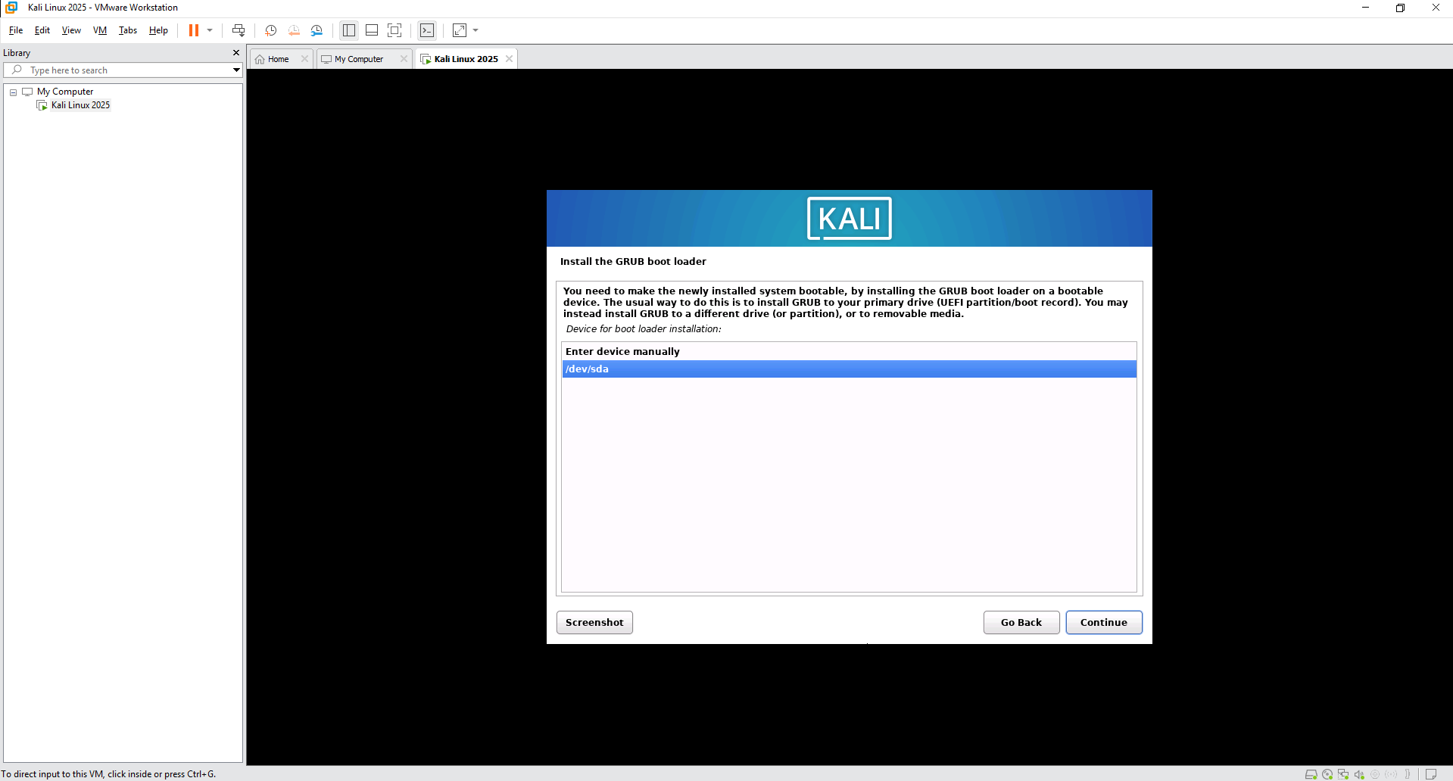
- On the Finish the Installation page, click Continue
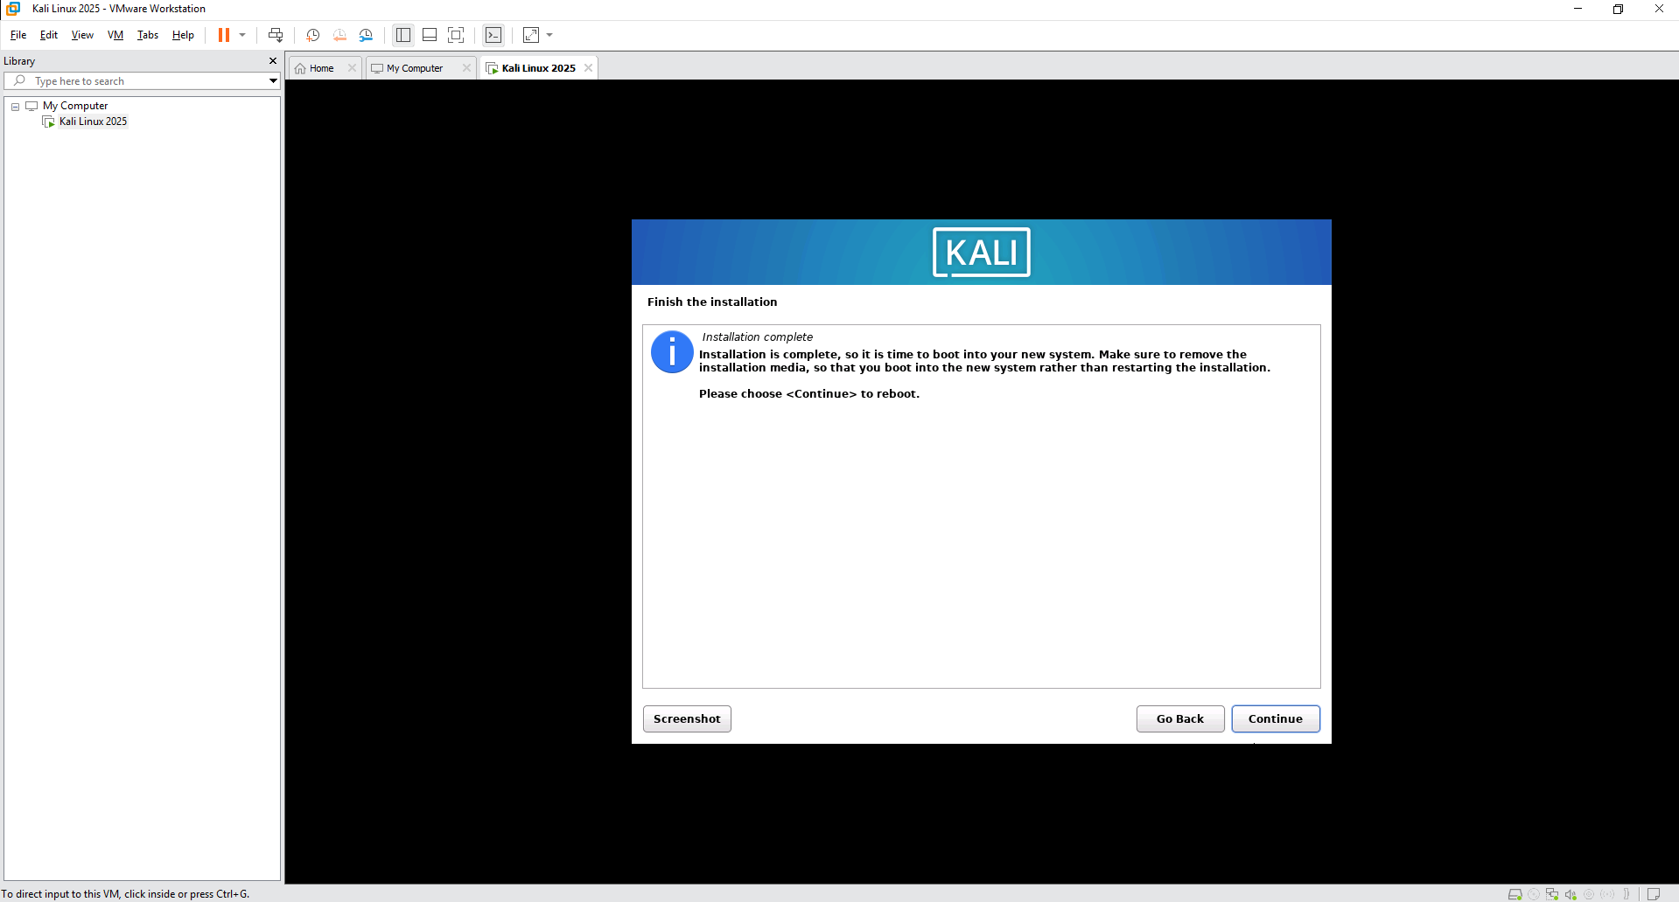
- The instal will finish and the Virtual Machine will reboot and load to the login screen
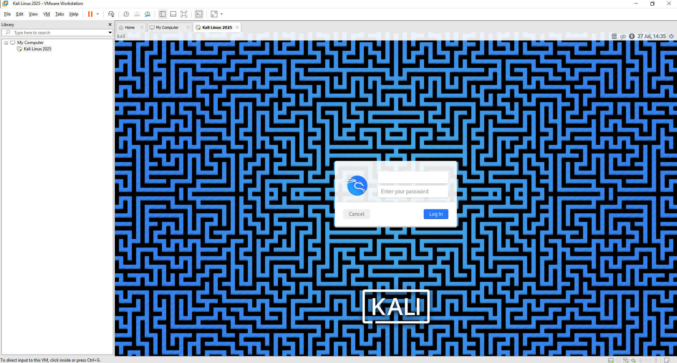
- Log in using Username: student and Password: toor
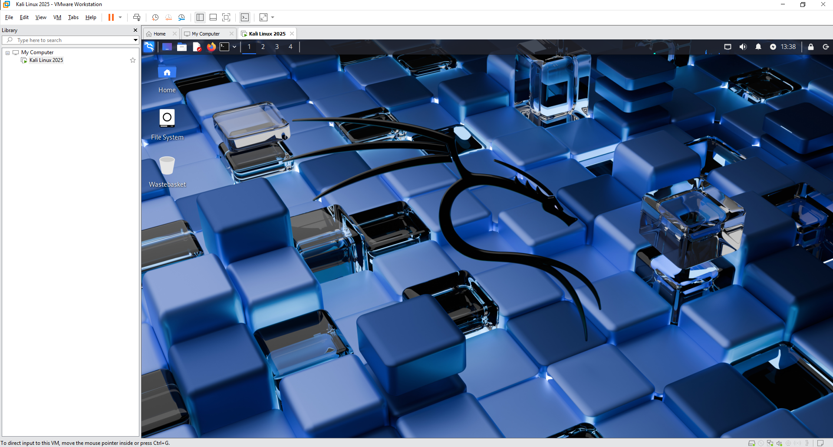
- The installation of Kali Linux 2025 is now complete.

